**Software Requirements**

**Specification**

**for**

**Request Tickets Management System**

**Version 1.0 approved**

**Prepared by**

**Ibañez, Shaun Mathew T.**

**Talosig, Buena Alexey Y.**

**Vertudes, Zian Denisse G.**

**Bariuan, Krisper Jane H.**

**MI 151**

**October 16, 2017**

***Copyright © 1999 by Karl E. Wiegers. Permission is granted to use, modify, and distribute this document.***

# Table of Contents

Table of Contents ii

Revision History ii

1. Introduction 1
   1. Purpose 1
   2. Document Conventions 1
   3. Intended Audience and Reading Suggestions 1
   4. Product Scope 1
   5. References 1
2. Overall Description 2
   1. Product Perspective 2
   2. Product Functions 2
   3. User Classes and Characteristics 2
   4. Operating Environment 2
   5. Design and Implementation Constraints 2
   6. User Documentation 2
   7. Assumptions and Dependencies 3
3. External Interface Requirements 3
   1. User Interfaces 3
   2. Hardware Interfaces 3
   3. Software Interfaces 3
   4. Communications Interfaces 3
4. System Features 4
   1. System Feature 1 4
   2. System Feature 2 (and so on) 4
5. Other Nonfunctional Requirements 4
   1. Performance Requirements 4
   2. Safety Requirements 5
   3. Security Requirements 5
   4. Software Quality Attributes 5
   5. Business Rules 5
6. Other Requirements 5

Appendix A: Glossary 5

Appendix B: Analysis Models 5

Appendix C: To Be Determined List 6

# Revision History

|  |  |  |  |
| --- | --- | --- | --- |
| **Name** | **Date** | **Reason For Changes** | **Version** |
|  |  |  |  |
|  |  |  |  |

# Introduction

## Purpose

The purpose of the system is to provide a requests tickets management system that will serve as a stepping stone for the corporation to achieve excellent services for the guests. By having the ability to review and analyze the requests, better and fast response will be given to the guests for their satisfaction.

The system will implement a ticketing module which includes the creation of tickets, the sending of tickets and the notifications about the tickets sent. The tickets created will contain the nature of the ticket itself, category, department involve and the time of the whole process. In addition, the tickets will be monitored. The ticket monitoring module will display the tickets with pending status and if the complaint remains unsolved, the complaint will be sent to the higher authority. Also, statistics about the complaint and requests will be provided by the business analysis module such as the tallying of the tickets based on nature, concerned departments, ticket generation and average time before the requests will be resolved. In addition, all employees are allowed to have a smart phone which will allow the system to notify all the employees. Also, all employees that are assigned to respond to the tickets have the ability to seek help from the higher authority by sending a message regarding the reason why the employee needed help.

## Document Conventions

## The main purpose of the project is to create a request ticket management system that will serve as a way of communication of the employees, guest service representative and also the executives of the company. The system aims to allow all the employees to review and analyze the tickets created by the guest service representative in a convenient way for faster services.

## Intended Audience and Reading Suggestions

The project manager, developers and documentation writers are the group of people working to create the system. It is crucial for the group to understand and know the documents to successfully create the proposed system. The users and testers, in addition, needs to understand the document as well to successfully know how to use the system created by the group. The importance parts of the whole document, however, are the Introduction and the method, results and discussion.

## Product Scope

The Request Tickets Management System will automatically monitor all the requests from the guests for the corporation that will be convenient to the employees of the corporation itself. The employees will easily monitor all the requests which will allow faster response resulting to having better quality of services.

The Request Tickets Management System will implement two modules. First is the

ticketing module that will include the process of ticket creation along with the process of sending of tickets and notifications. Another module of the system is the business analytics module that will include the statistics such as the tallying of the tickets based on their nature, ticket generation, responsible departments and average time of the whole process.

## References

Customer satisfaction is significant for it defines the summary a customer had with the hotel or the service. (Cronin and Taylor, 1992).

Customer satisfaction also talks about responding quickly to issues and is more than just a smile when greeting one. (Martins, 2013)

Moreover, loyal customers are important to organizations because “it costs three to five times as much to attract new guests than to retain existing ones” and past guests can invite more people by recommendation. (Conlon et al., 2004)

A customer relationship management helps to engage, get and maintain customer engagements in long term goals. (Balagosa, 2014) Customer requests are fundamental in organizations and hotels. The managers must seek the importance of resolving these issues as quickly as possible. To attract a new customer, it costs 5 times than to keep the exiting one. (Blodgett et al., 1995)

# Overall Description

## Product Perspective

The system is a replacement for the current process of the company in handling guest requests. The proposed system will automatically monitor all the requests from the guests for the corporation that will be convenient to the employees of the corporation itself. The employees will easily monitor all the requests which will allow faster response resulting to having better quality of services.

## Product Functions

* A dashboard will be created for the guest service representative. The guest service representative will be able to create, view and send the tickets.
* A mobile application will be created for the employees and the executives. The system will allow the employees to receive tasks to resolve the request of the guests. The application will show the tickets that need to be resolved. However, if the ticket remains unsolved and it exceeded the allotted time, the system will automatically notify the executives.

Here is the object class diagram of the RTMS:

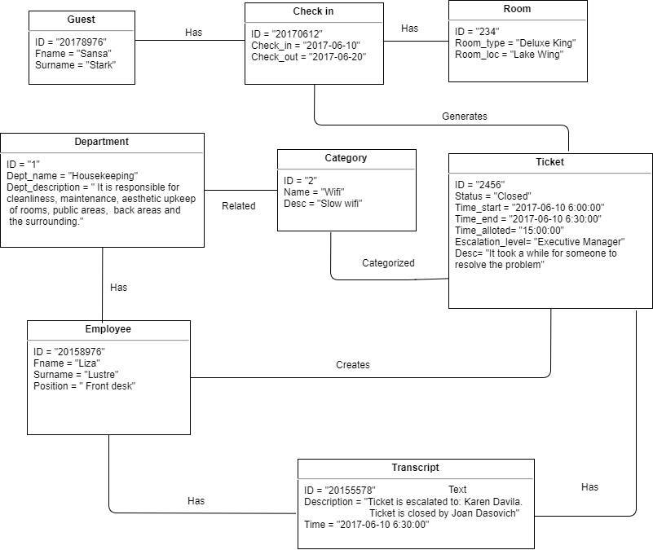

## User Classes and Characteristics

The Guest Service Representative of the hotel will be responsible in the creation of ticket and sending the created tickets in the department responsible. The Guest Service Representative must create the ticket as soon as a guest calls. Another group of users are the employees. By using the system, the employees are capable of viewing the tickets that needs to be resolved. Lastly, the executives will have the capability to know whether the employees are resolving the requests. If a tickets remains unsolved and it exceeded the allotted time, the system will automatically notify the executives.

## Operating Environment

The Request Ticket System will be used by SM Hotels during their operations. The system will be installed in mobile devices to ensure mobility of employees handling the devices to communicate with each other even if the employees are not in the same area. The Front Desk department will be handling the back-end PC where the tickets will be created which will be sent to the mobile phones of the employees that will be assigned to handle the request or complaint. These tickets will be updated per action and stored in the database and will be written in a transcript in order for an Executive or Manager to review and make a report. This report will serve as their basis for improving the service of the customer.

## Design and Implementation Constraints

The client claimed that only selected employees will be allowed to use smart phones during work. It will be difficult for the group to create an idea on how to notify all the employees for faster services of the hotel.

## User Documentation

**Overview**

The mobile application of Tickets Management System have functions that will enable each user to view a request or complaint, input necessary details to the ticket for it can reach the departments involved in resolving the request or complaint and escalate the ticket to higher ups if the ticket is not yet resolved.

There are 3 specific users that are involved in the system. Employee, supervisor and front desk.

## Which devices does the mobile app support?

You can install the given application on any mobile devices that have Android (mobile phones and tablets) operating systems.

## Basic Steps for Employee:

* + 1. 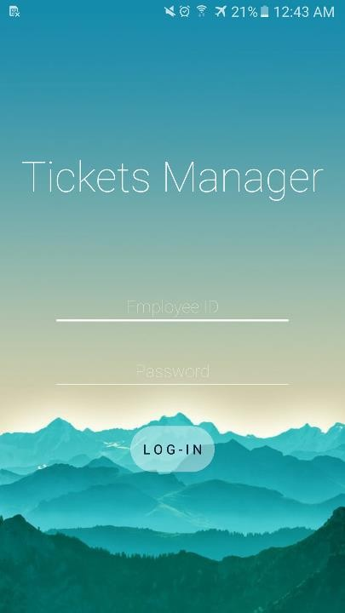Login using their user credentials

This login screen is for all the employees in the hotel. Housekeeping attendants, supervisors in charge and also the front desk representative.

In this screen, the employee should enter his/her employee id and also the password to access the application.

* + 1. Receive tickets and viewing the ticket along with the ticket details
    2. Notify the higher up through sending a message
    3. Viewing of the ticket history

## Basic Steps for Guest Service Reporsentative:

* + - 1. Login using their user credentials
      2. At the home screen, click the create ticket button.

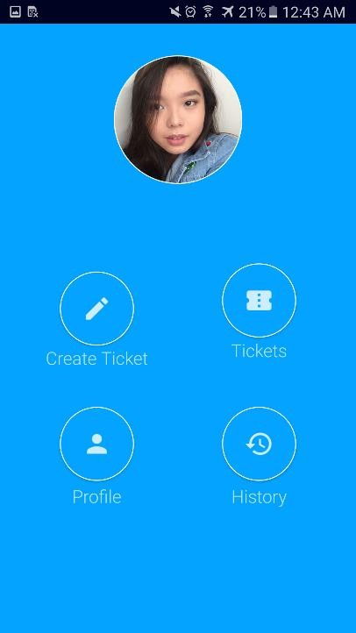

* + - 1. ****A create ticket screen will appear, input necessary details.

****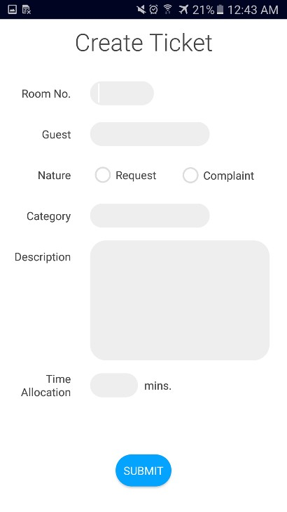

## Basic Steps for Supervisors (Higher Ups)

1. Login using their user credentials
2. Viewing the ticket along with the ticket details when escalated

## Assumptions and Dependencies

The department heads doesn’t need to assign an employee for the ticket created by the front desk. The system will automatically send the generated ticket to the employees working on a particular shift.

# External Interface Requirements

## User Interfaces

## Home Screen

## 

## All employees using the app will have an image icon of themselves.

## All employees will have the option to View Tickets

## Only the Guest Service Representative will have the option to create a ticket

## The Home screen will have a back button and home button if the employee wishes to go back to the home screen of their phone

## Create Ticket Screen

## 

## Only Guest Service Representative will have access to the Create Ticket Screen

## This screen will be requiring all the fields to be completed

## If the fields are incomplete, a toast will appear showing the message “Incomplete Entry”

## If the fields are completed and then the representative presses the Submit button, the app will return to the home screen

## A back button will be provided for an option to go back to the home screen of the app

## 

## View Ticket Screen

## 

## All employee will have access to view all tickets created by the Guest Service Representative.

## The Tickets will contain all the necessary data that an employee would need to serve the guests.

## A back button will be provided for an option to go back to the home screen of the app



## Hardware Interfaces

Request Tickets Management System is a mobile application intended to be installed in an android smartphone and table to endure mobility and efficient communication between the Guest Service Representative and the employee of all department when it comes to serving the guest. The mobile application will be supported by a back-end PC or a node PC which will be handled by a Guest Service Representative. The node PC can also be seen by the Managements in order to keep track of the status of the hotel’s Customer Satisfaction for the improvement of the hotel’s services and also receive good feedback to lure in more guests.

## Software Interfaces

The Request Tickets Management System’s mobile application is being developed using Android Studio which can be installed in a mobile device (Smartphone or Tablet) running an Android Application. The back-end will be developed using NetBeans IDE 8.2. under Java Web Application. The Database can be accessed through PHPMyAdmin. When creating a ticket, the data will be inserted into the database since the web application will be connected to the database using a MySQL Java Connector. Then via our Web Service, the Mobile App will also be able to insert data into the database. Both Mobile Application and the Web Dashboard will be able to view the Tickets, which contains the data needed to properly serve the customer.

**3.4 Communications Interfaces**

****The Request Tickets Management System mobile application will have a network server that is web-based which will be created using PHP (Hypertext Preprocessor) where the Database will also be contained. For the web application, the dashboard will be connected to the MySQL server, which is in the same network server of the mobile application, using JDBC (Java Database Connectivity). The server was made to insert data into the database, pull data from the database, and send notifications to the Employee’s mobile devices. All of the Mobile devices will be connected the same network in order for these devices to communicate with each other.

# System Features

## System Feature 1: Creating Ticket

### Description and Priority

### High Priority

### Stimulus/Response Sequences

### Step 1: Login Screen, this screen shows the logo and the name of the application. The user (guest service representative) will need to input his/her employee ID and password.

### Step 2: Home Screen, a button which is a create ticket will be shown to the guest service representative with a viewing tickets icon/button.

### Step 3: Create Ticket Screen, this screen will show different fields that will serve as the details of the ticket. (category, room number.. etc) If the fields are incomplete, theuser will not be able to submit it.

### Functional Requirements

### The ticket then would be saved in a database.

## System Feature 2: Viewing Ticket

### Description and Priority

### High Priority

### Stimulus/Response Sequences

## 

### Step 1: Login Screen, this screen shows the logo and the name of the application. The user (guest service representative) will need to input his/her employee ID and password.

### Step 2: Home Screen, a button which is a view ticket will be shown to the guest service representative with a create tickets icon/button.

### Step 3: Viewing Ticket Screen, is where the user will be able to see the open and closed tickets and if the tickets are escalated to the higher ups.

4.2.3 Functional Requirements

To have the ticket viewing, the system should be connected to a real time database.

## System Feature 2: Reports Analysis

## 

### Description and Priority

### High Priority

### Stimulus/Response Sequences

## 

### Step1: Open the Dashboard, the dashboard is also another platform to create tickets and to view tickets. However the dashboard will provide the reports analysis of the tickets.

### Step 2: Click the reports and analysis button, this will show the analysis of tickets inputted within the day. The user then can also choose on how to view it in a different category.

4.2.3 Functional Requirements

To have the reports analysis, the system should be connected to a real time database.



# Other Nonfunctional Requirements

## Performance Requirements

The new ticket should only take a few seconds to be in the database. Viewing and creating are not an issue to system for the system would have a real time database.

## 5.2 Safety Requirements

The Requests Ticket Management System will not affect any applications installed on the smartphone or any internal components on it.

## Security Requirements

The Requests Ticket Management System can only allowed employees that are registered to do the viewing ticket.

## Software Quality Attributes

The Requests Ticket Management System has a user friendly interface that is good for the employees to navigate. The application then will deal with submitting correct data to be able to obtain a clear and concise analyzed reports.





## Business Rules

The Requests Ticket Management System includes the Guest Service Representative, Employees which are from different departments, and the Executives. The guest service representative will only be the one who will create the ticket, and the employees are the first ones who will view it and the executives will be notified if the requests is not yet resolved with the allotted time.

# Other Requirements

# Here are the details and the needed data that the database should have.

# C:\Users\Krisper Jane\Documents\PBL\Wiki Photos\12.PNG

# C:\Users\Krisper Jane\Documents\PBL\Wiki Photos\13.PNG



# C:\Users\Krisper Jane\Documents\PBL\Wiki Photos\14.PNG

# C:\Users\Krisper Jane\Documents\PBL\Wiki Photos\15.PNG

# C:\Users\Krisper Jane\Documents\PBL\Wiki Photos\16.PNG

# C:\Users\Krisper Jane\Documents\PBL\Wiki Photos\17.PNG

# Appendix A: Glossary

# Ticket – The request that needs to be rendered

# SMHCC - ShoeMart Hotels and Conventions Corporation

# 

# 

# 

# Appendix B: Analysis Models

**ERD MODEL:**

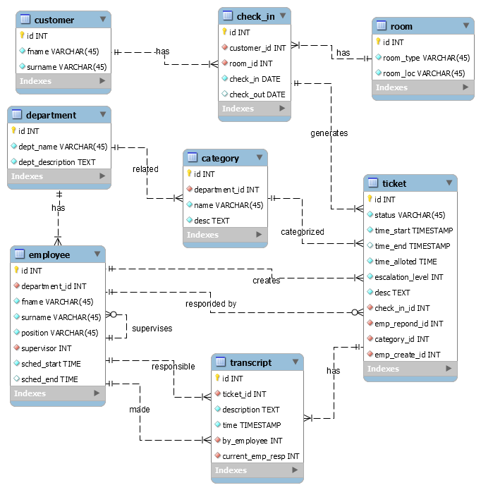





**Composite Diagram:**

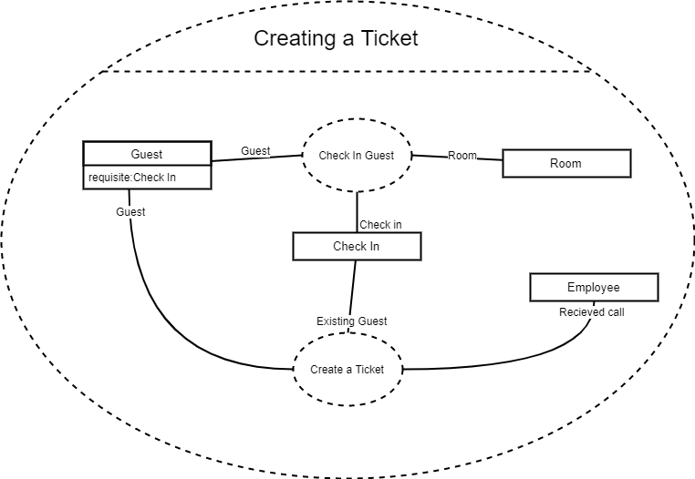





**Class Diagram:**

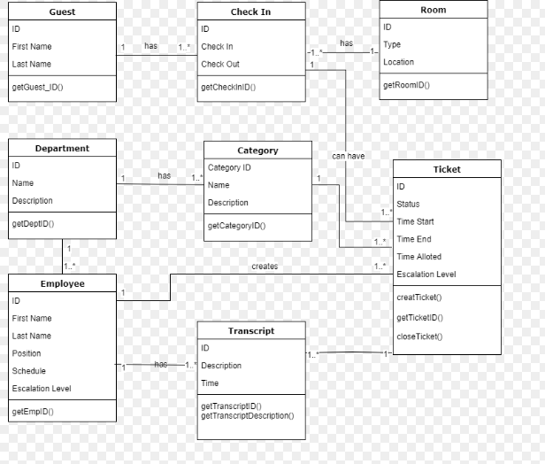







# Appendix C: To Be Determined List

There are no remaining TBDs.

